GUJARAT TECHNOLOGICAL UNIVERSITY

Chandkheda, Ahmedabad

 Affiliated



**New L J Institute of Engineering and Technology**

A

Project Report

On

**YOUTH EMPLOYMENT OPPORTUNITIES**

Under subject of

DESIGN ENGINEERING-IA

B. E. II, Semester – IV

Computer Science Engineering (Artificial Intelligence & Machine Learning)

Submitted by:

**Group: CSE-24 ID: 354189**

**Sr No. Name of student Enrollment No**.

1. UNNATI JAGDISH PARIKH 201430142005
2. DIYA RAKESHKUMAR BODIWALA 201430142062
3. KSHITI PRANAV MULANI 201430142077
4. SHASHVI KAUSHALBHAI SHAH 201430142127

**Prof. Pooja Vyas**

(Faculty Guide)

**Prof. Saurin Dave**

Head of the Department

Academic Year: 2021-2022

**CONTENTS**

|  |  |
| --- | --- |
| **SR NO.** | **TITLE** |
|  |  |
| 1 | Introduction |
|  | 1. Design thinking and its importance |
|  | 1. Project Summary |
| 2 | AEIOU Canvas |
|  | 1. Mind Map |
| 3 | Empathy Mapping |
| 4 | Ideation Canvas |
| 5 | Product Development Canvas |
|  | 1. Prototype |

6 Learning Need Matrix

1. **INTRODUCTION**

**1.1 DESIGN THINKING:**

* Design engineering is the creative process of identifying needs and then devising a solution to fill those needs.
* This solution may be a product, a technique, a structure, a project, a method, or many other things depending on the problem.
* The general procedure for completing a good engineering design can be called the engineering method of creative problem-solving.
* Problem-solving is the process of determining the best possible action to take in a given situation.
* The nature of problems that engineers must solve varies between and among the various branches of engineering.

**1.2 PROJECT SUMMARY:**

The government has made many provisions for the socially backward class people and the rural people to have basic primary education to uplift their lives. But the people are unable to access these benefits due to a lack of detailed knowledge about those schemes and the language barriers. So, to uplift their lives, our team has decided to build a platform to explore government projects.

We had made visits to the rural places and interacted with many people. We had different observations about their problems and their reasons.

We wanted to make a change in society. Education is one of the ways to bring the best from individuals. Some are not privileged to get an education due to various reasons. The government has provided schemes but their awareness has not reached many minds. In this world of screens, providing the information for their careers can be a better solution.

After noting various solutions to the problem, we came to the result to develop a website. Our project gives benefits to the users who want to bring a significant change in their lives through education which is not limited to rural people but also every citizen who wants to get information. This idea would be implemented using a website that can reach the maximum number of people. We have used the asp.net platform with java as our programming language. We have functions like details of job opportunities, direct links to courses, and e-books. We have features like availability of resources, language accessibility, and video-based resources. This project requires a data admin that keeps the details updated on the site as well as the collection of video links and e-books. The sources of these links need to be referenced on the site.

1. **AEIOU CANVAS**

* **Activities**
* **Environment**
* **Interaction**
* **Objects**
* **Users**

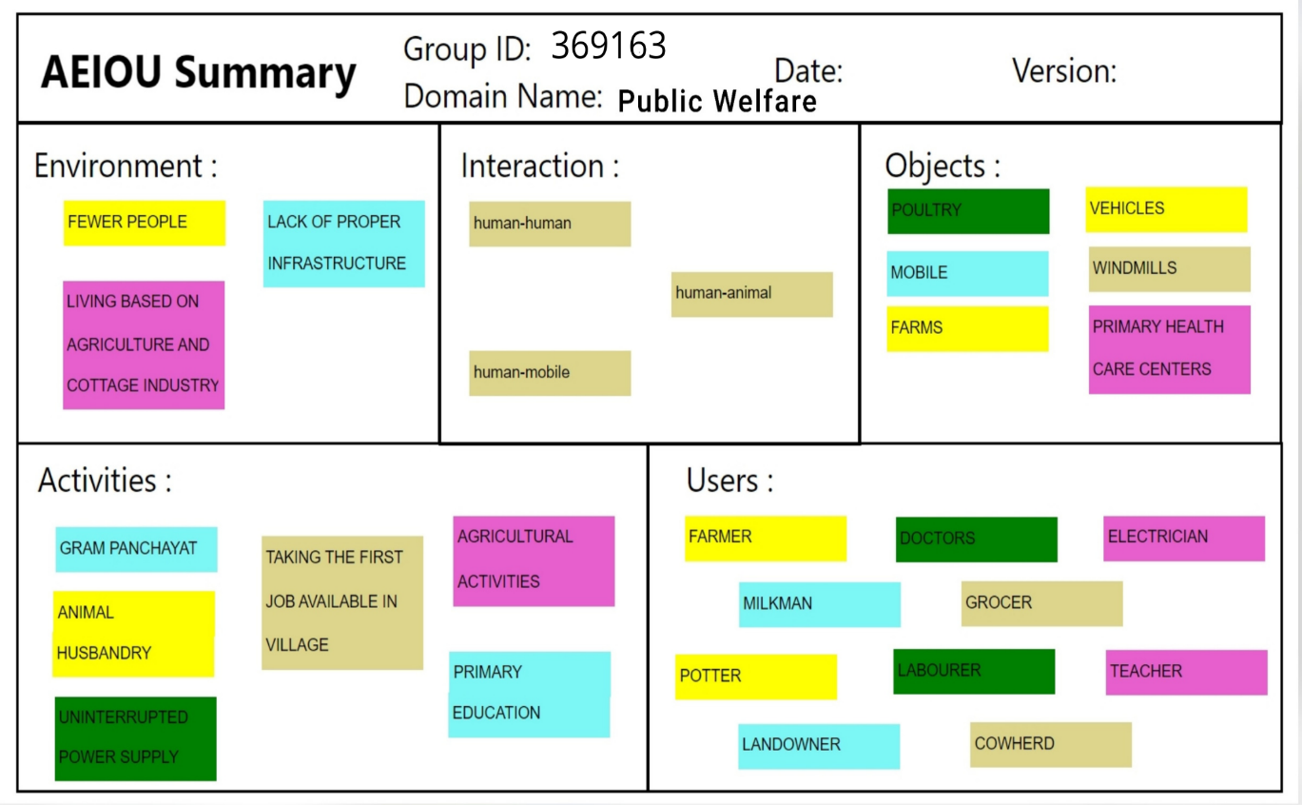

* **Activities**

**It includes activities occurring at the place of observation:**

* Gram Panchayat
* Animal Husbandry
* Agricultural activities
* Taking the first job available in the village
* Primary Education
* **Environment**

**It includes the surrounding atmosphere of the place of observation**

* Fewer people
* Lack of proper infrastructure
* Living based on agriculture and cottage industries
* **Interactions**

**It includes interactions occurring among various people**

* Human-Human
* Human-Animal
* Human-Mobile
* **Objects**

**It includes different objects at the place of observation**

* Poultry
* Farms
* Mobiles
* Vehicles
* Windmills
* Primary Health Care centers
* **Users**

**It includes people who are present at the place of observation**

* Farmers
* Doctors
* Electrician
* Milkman
* Grocer
* Potter
* Teacher
* Laborer
* Land Owner
* Cowherd
  1. **MIND MAP**

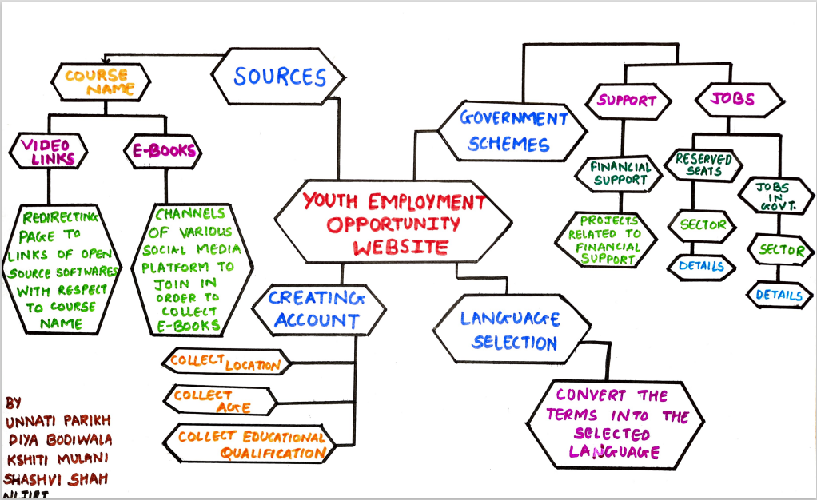

1. **EMPATHY MAPPING**

* **Users**
* **Stakeholders**
* **Activities**
* **Story Boarding**

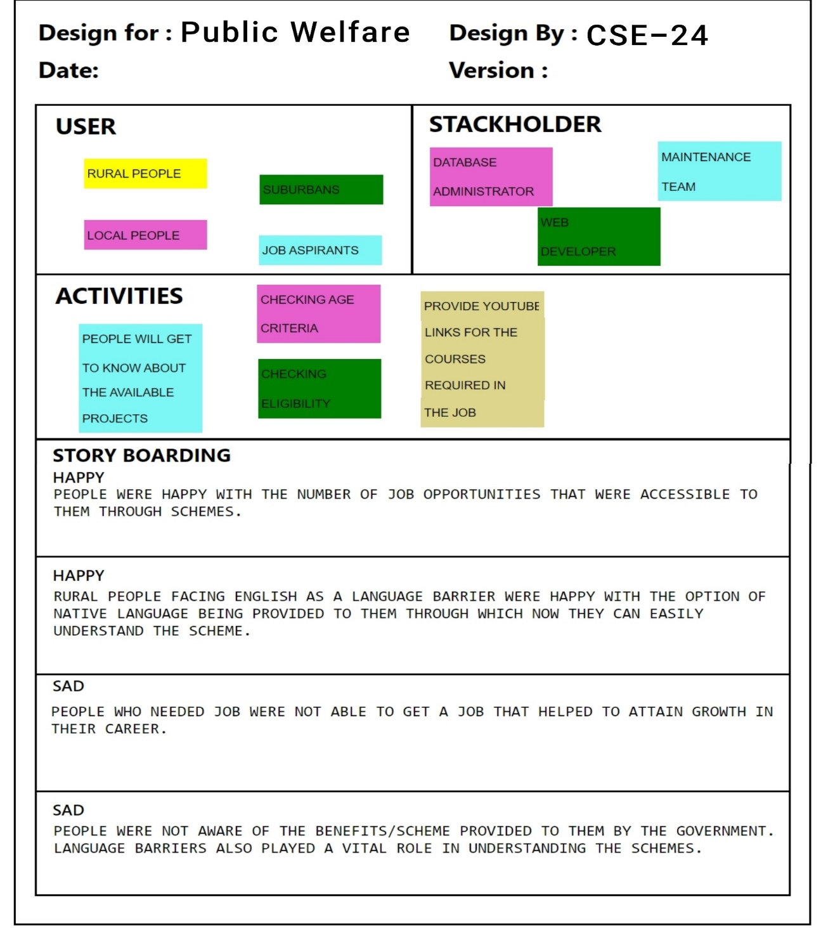

* **User**

**It includes people who are present at the place of observation.**

* Rural people
* Suburban
* Local people
* Job Aspirants

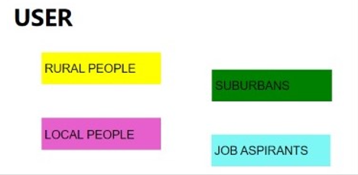

* **Stakeholders**

**It includes people who are indirectly related to the environment i.e. third party service**

* Database Administrator
* Maintenance Team
* Web Developer

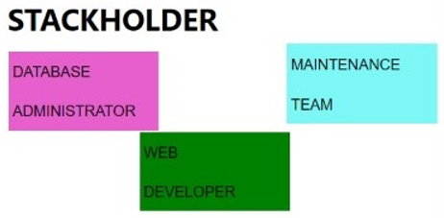

* **Activities**

**It includes events occurring at the place of observation**

* People will get to know about the available projects
* Check eligibility
* Check age criteria
* Provide video links for courses required in the job

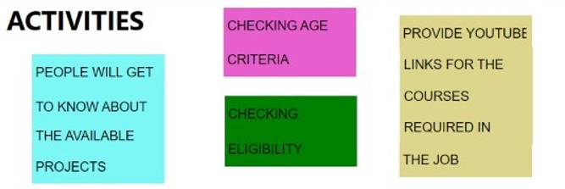

* **Story Boarding**

**Happy Stories:**

It includes two stories at the place of observation whose outcome was happy.

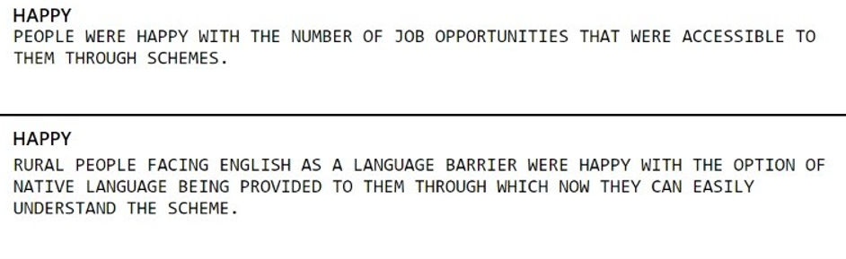

**Sad Stories:**

It includes two stories observed at the place of observation whose outcome was sad.

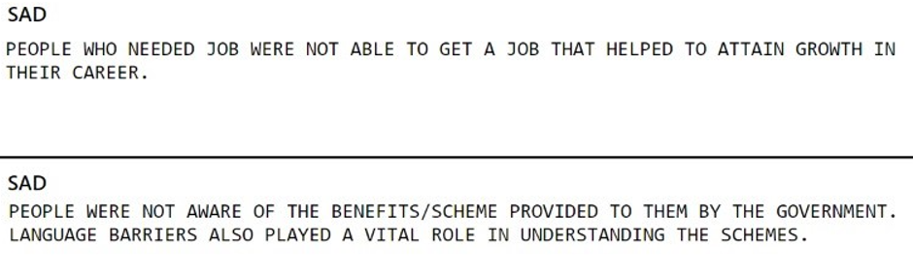

1. **IDEATION CANVAS**

* **People**
* **Activities**
* **Situation/Context/Location**
* **Props/Possible Solutions**

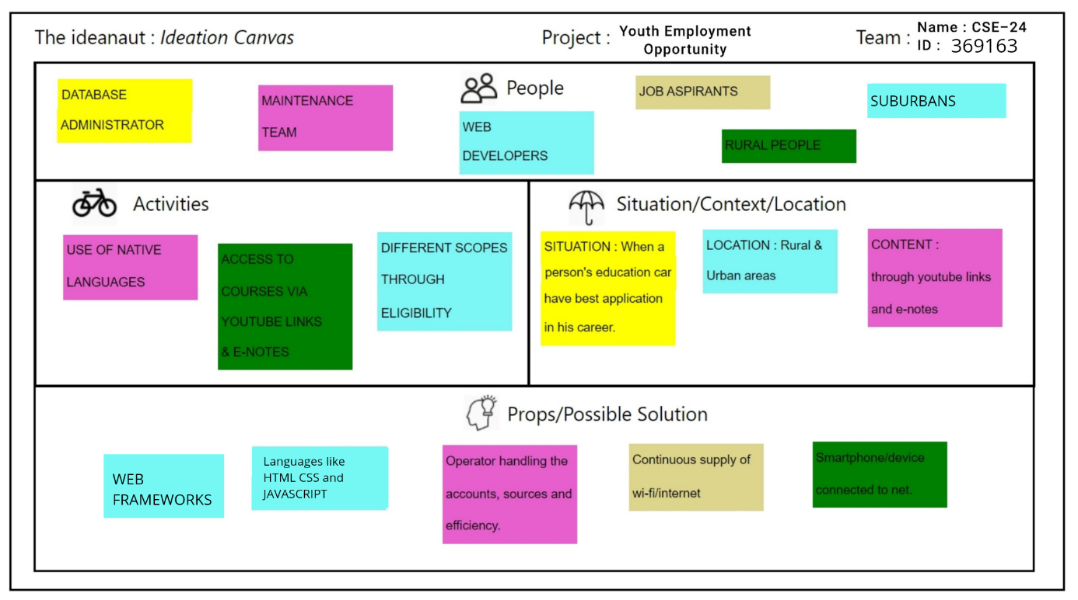

**People**

**It includes several people related to the project directly or indirectly.**

* Database Administrator
* Maintenance Team
* Web Developer
* Job Aspirants
* Rural People
* Suburban

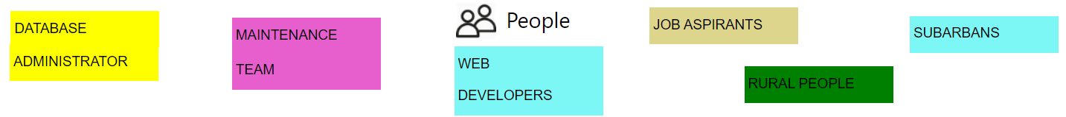

**Activities**

**It includes events occurring at the place of observation.**

* Use of native language
* Access to courses via YouTube links
* Different scopes through eligibility

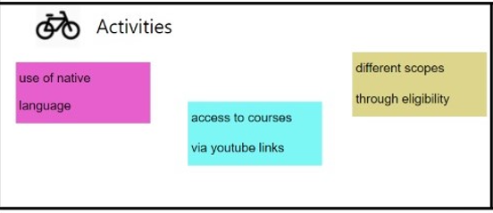

**Situation/Context/Location**

**It includes places where the mentioned activities might occur.**

* Situation: When a person’s qualification has no best application in his career.
* Location: Rural and urban areas
* Content: Video links

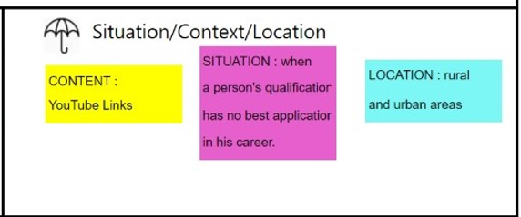

**Props/Possible Solutions**

**It includes various ways to solve a given problem.**

* Web Frameworks
* Languages like HTML, CSS and JavaScript
* Continuous supply of internet
* Smartphones available to all
* Operators handling the accounts, sources, and the efficiency

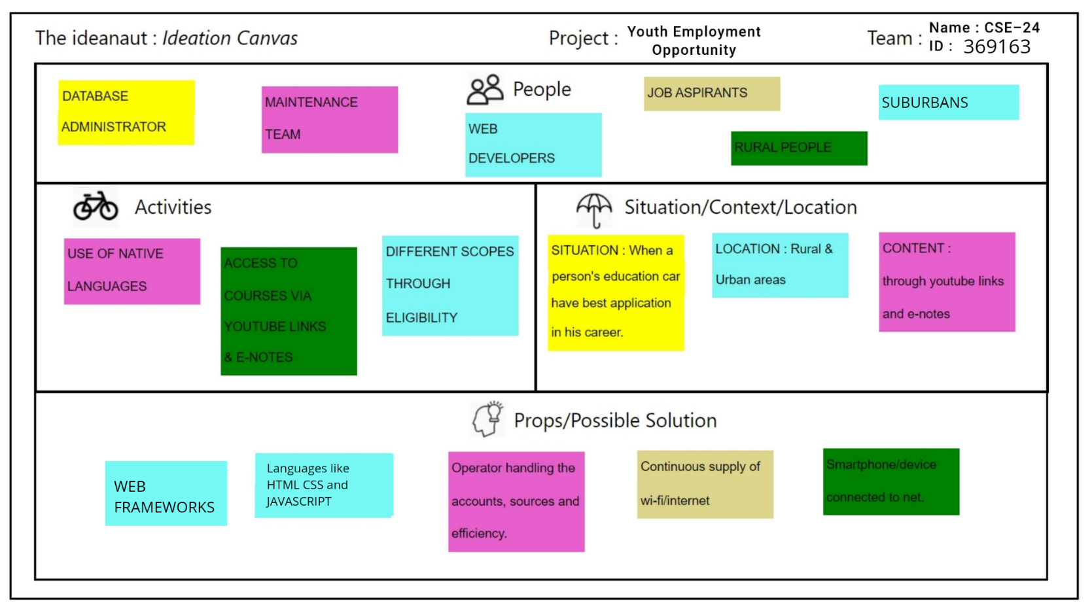

1. **PRODUCT DEVELOPMENT CANVAS**

* **Purpose**
* **People**
* **Product Experience**
* **People Function**
* **Product Features**
* **Components**
* **Customer Revalidation**
* **Reject, Redesign, Retain**

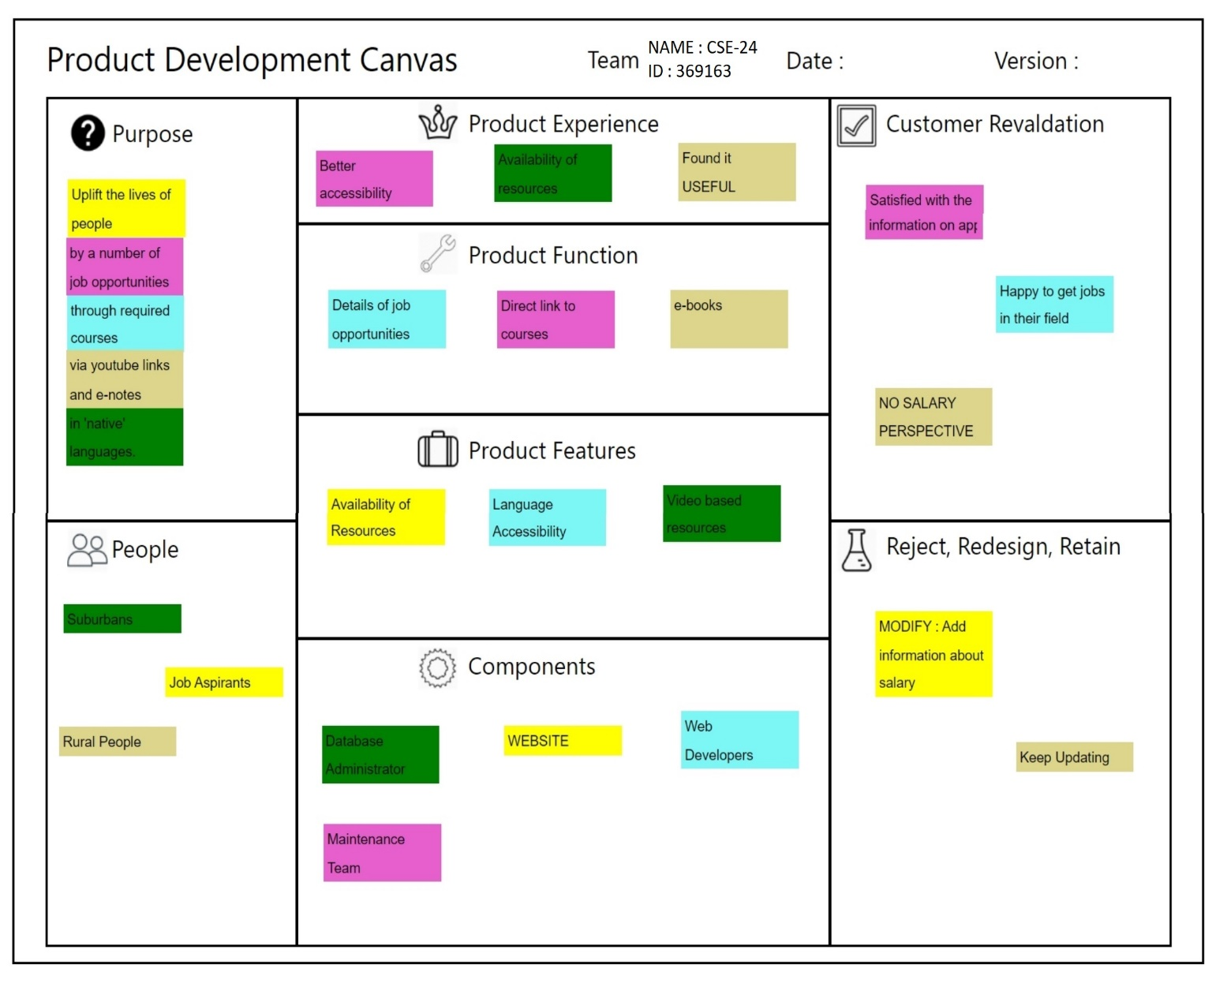

* **Purpose**

**It states the purpose of the project:**

Uplift the lives of people by several job opportunities through requires courses via YouTube links and e-notes in their native languages.

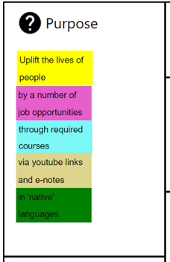

* **People**

**It includes people related to the product**

* Job Aspirants
* Sub-Urban
* Rural People

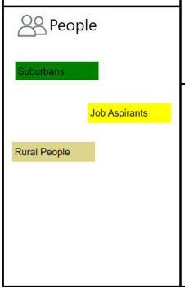

* **Product Experience**

**It states the experience of the product by the user**

* Better accessibility
* Availability of resources
* Found it useful

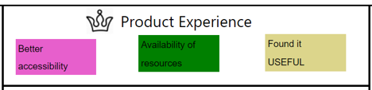

* **Product Function**

**It states the function of the product**

* Details of job opportunities
* Direct link to courses
* E-books

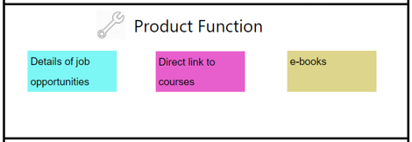

* **Product Features**

**It states the features of the product**

* Availability of resources
* Language Accessibility
* Video-Based Resources

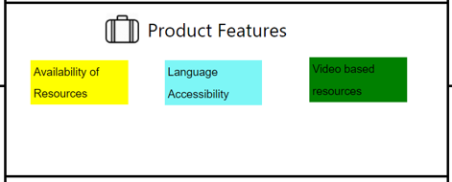

* **Components**

**It includes things that are needed for the product**

* Website
* Web Developers
* Database Administrator
* Maintenance Team

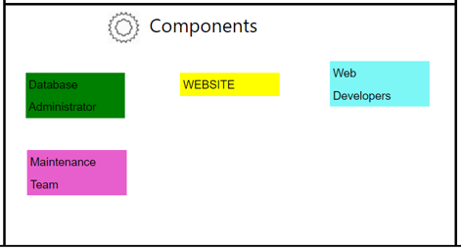

* **Customer Revalidation**

**It includes reviews of the customers that used the product**

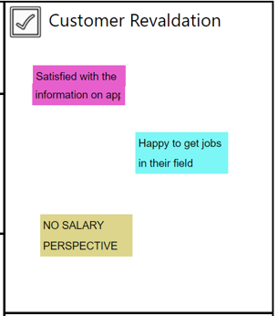

* **Reject, Redesign, Retain**

**It includes features that are rejected or asked to be redesigned or features that are retained.**

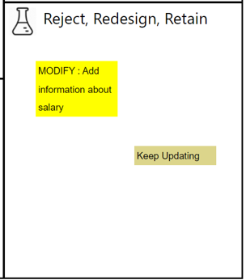

**5.1 PROTOTYPE CANVAS**

***Flowchart:***

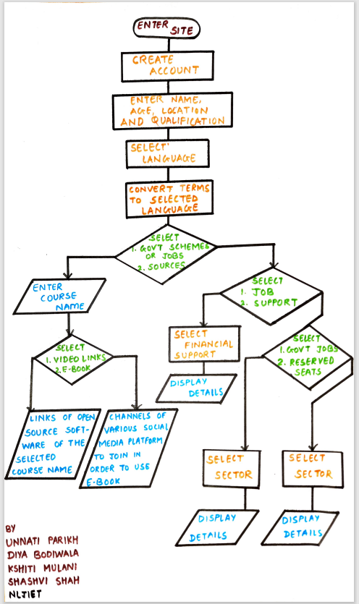

1. **LEARNING NEED MATRIX**

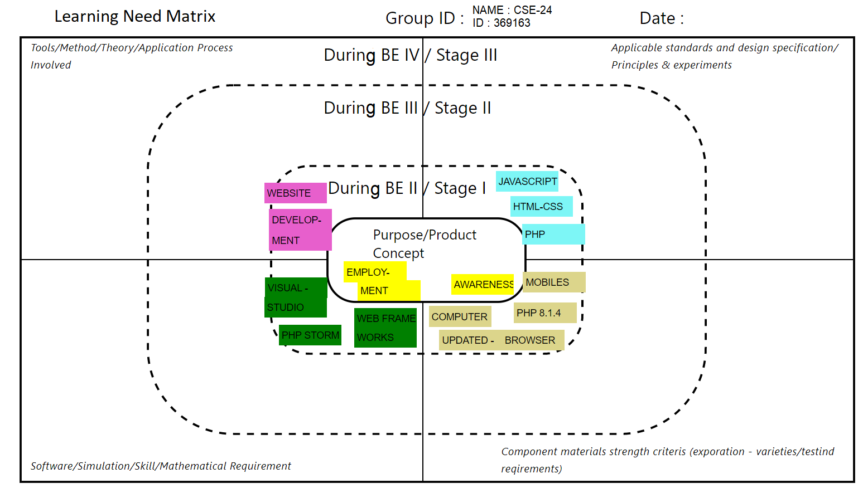

* **Purpose/ Product Concept**

**It includes the main idea behind the design.**

* Employment
* Awareness
* **Tools/Method/Theory/Application Process Involved**
* Website Development
* **Applicable standards and design specification/ Principles & experiments**
* JavaScript
* HTML-CSS
* PHP
* **Component materials strength criteria (exploration – varieties / testing requirements)**
* Mobiles
* Computer
* PHP 8.1.4
* Updated browsers
* **Software/Simulation/Skill/Mathematical Requirement**
* Visual Studio
* PHPStorm
* WebFrame Works